# Actual procedure

## Step-1

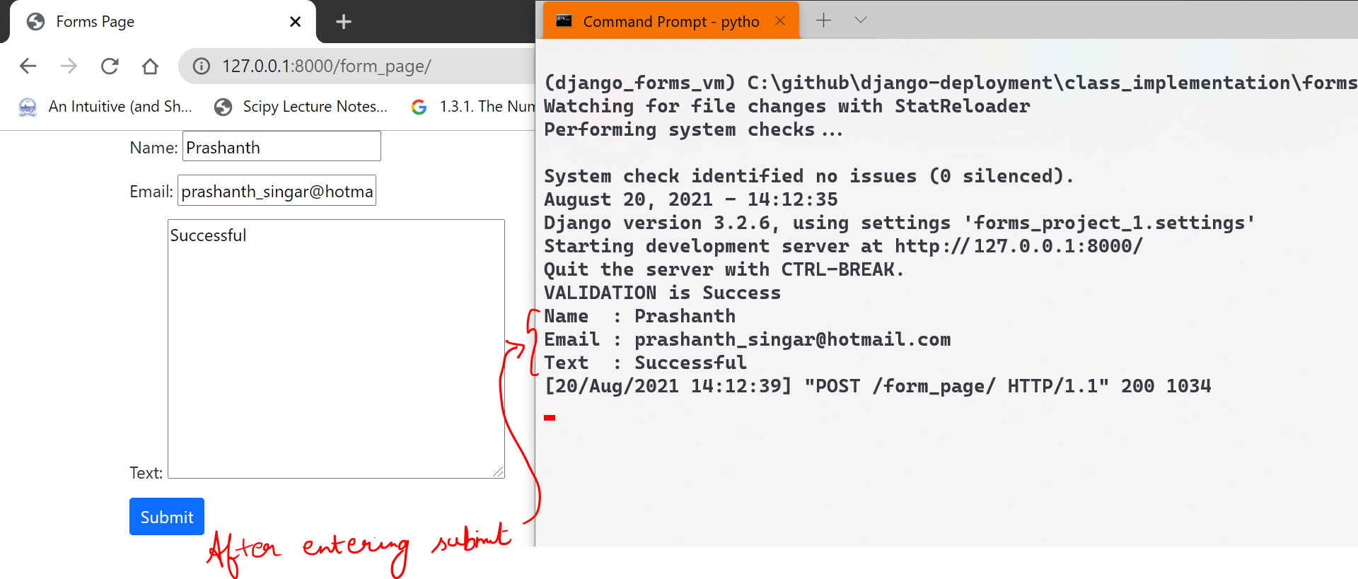  
Purpose of CSRF

# **Form validation**

Bots will not enter the data in the text field, rather they will feed the data directly into the html inspect <input>.  
now we are going to catch the bot.

Every time when we use our own custom validator   
“def clean_<the field name that you want to check>”

## **Checking passwords attempt**

